What was life like for children in Victorian London?

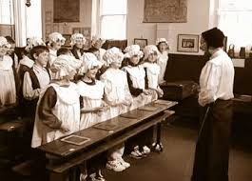
Victorian children lived very different lives to children today. Poor children often had to work to earn money for their family. As a result, many could not go to school.

A simple thing like crossing the street in Victorian London could be dirty and dangerous. London’s streets were dirty because horses were used as a method of transport and they left a lot of horse muck behind. Sweepers cleared the way for rich people to cross the road without dirtying their clothes.
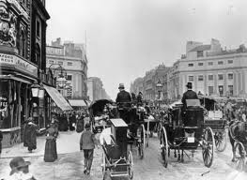

Many Londoners died from illnesses such as cholera, measles and scarlet fever. Even those in rich families died because of poor medical knowledge.
Parents might die at a young age so London had many orphans, rich and poor. Orphans who could not find a place in an orphanage sometimes had to live on the streets or in workhouses. Workhouses provided food and shelter in return for hard, unpleasant work. Conditions were very harsh and people would only go to workhouses as a last resort.
